Installation of Jenkins in MAC:

Mac installation happens using homebrew and below are the commands to be executed in order to install the jenkins

* Install the latest LTS version: brew install jenkins-lts if it installs properly you will get the below password on default port number 8080
  + You need to start using this password in https://localhost:8080/

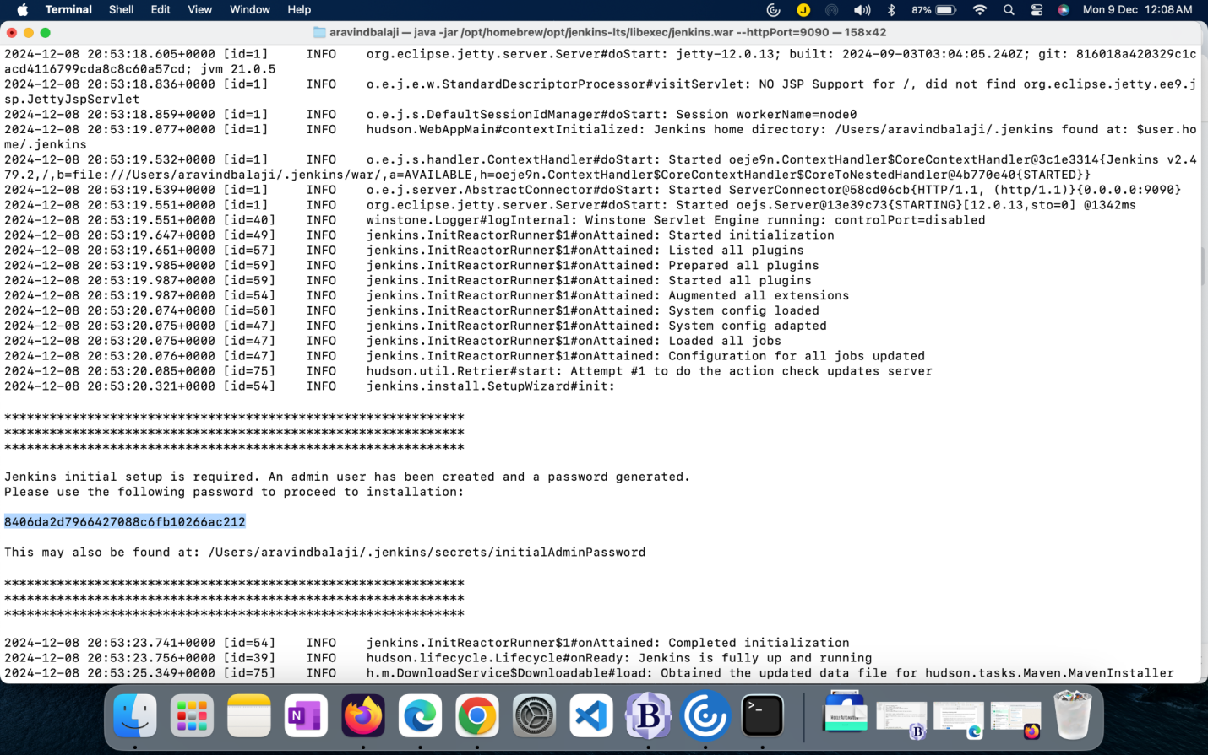

**For MAC Users:**

* Start the Jenkins service: brew services start jenkins-lts
* Restart the Jenkins service: brew services restart jenkins-lts
* Update the Jenkins version: brew upgrade jenkins-lts

The above commands run jenkins on default port 8080 if it does not work use the below command to run in other ports number with below command,

**/opt/homebrew/opt/openjdk@21/bin/java -jar /opt/homebrew/opt/jenkins-lts/libexec/jenkins.war --httpPort=9090**

**For windows users to start jenkins if installed via war file :**

1. Navigate tgo the path where the war file is available in the command prompt  
   2.Then execute the below command from the command prompt

java -jar jenkins.war

Now you need to run open the jenkins using <https://localhost:9090> and setup as below screenshot

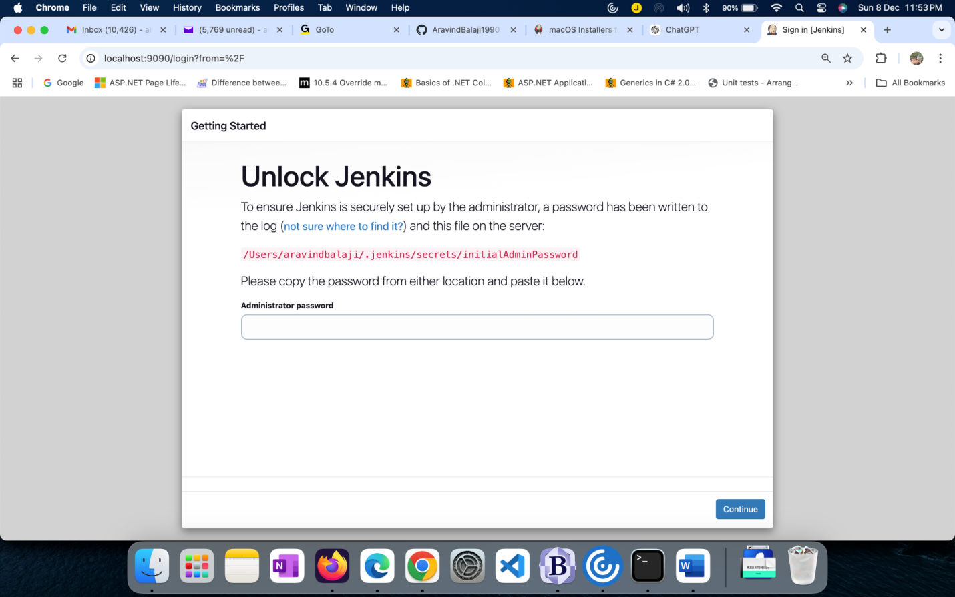

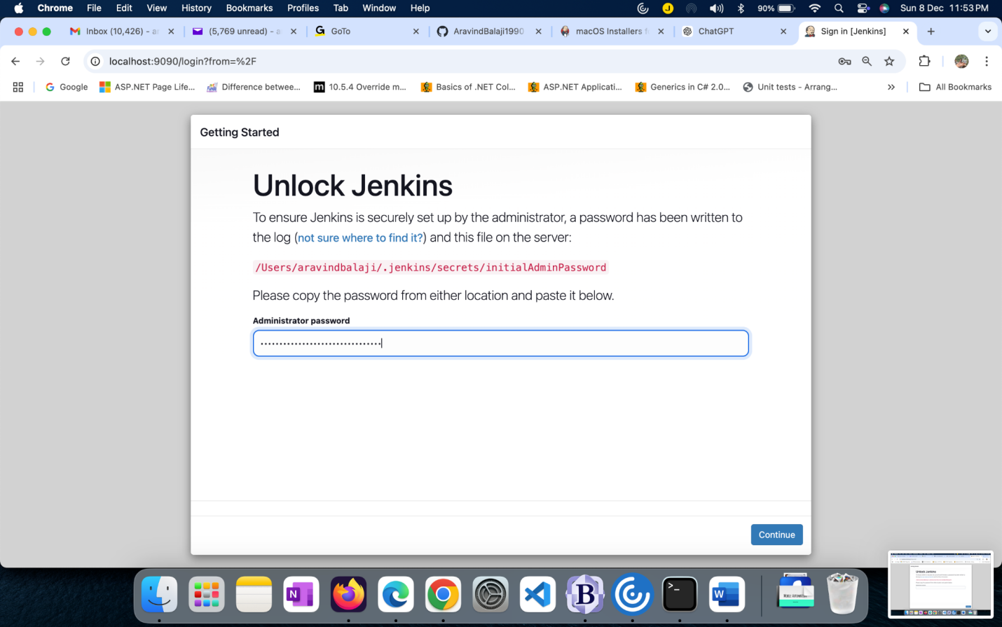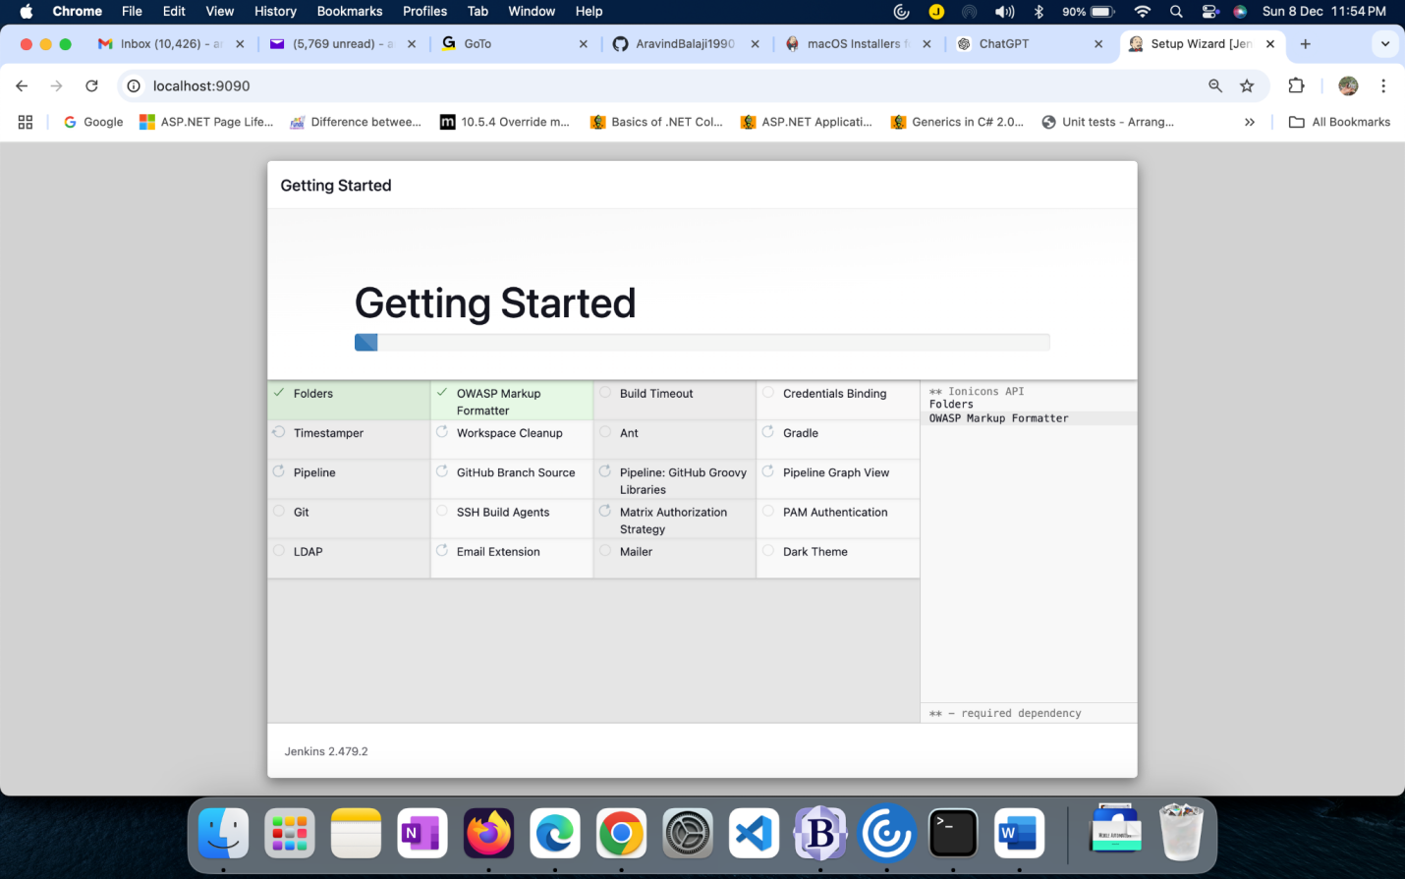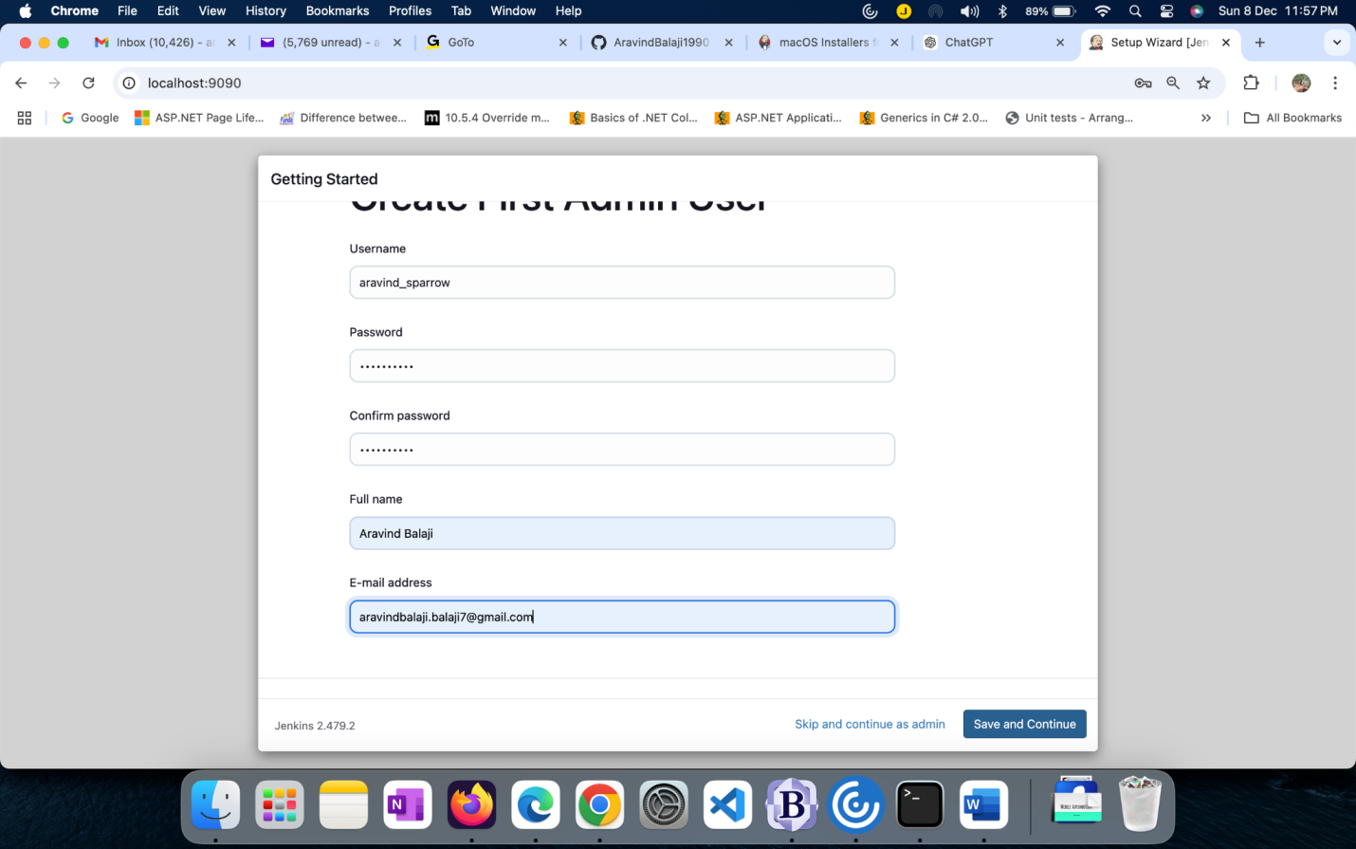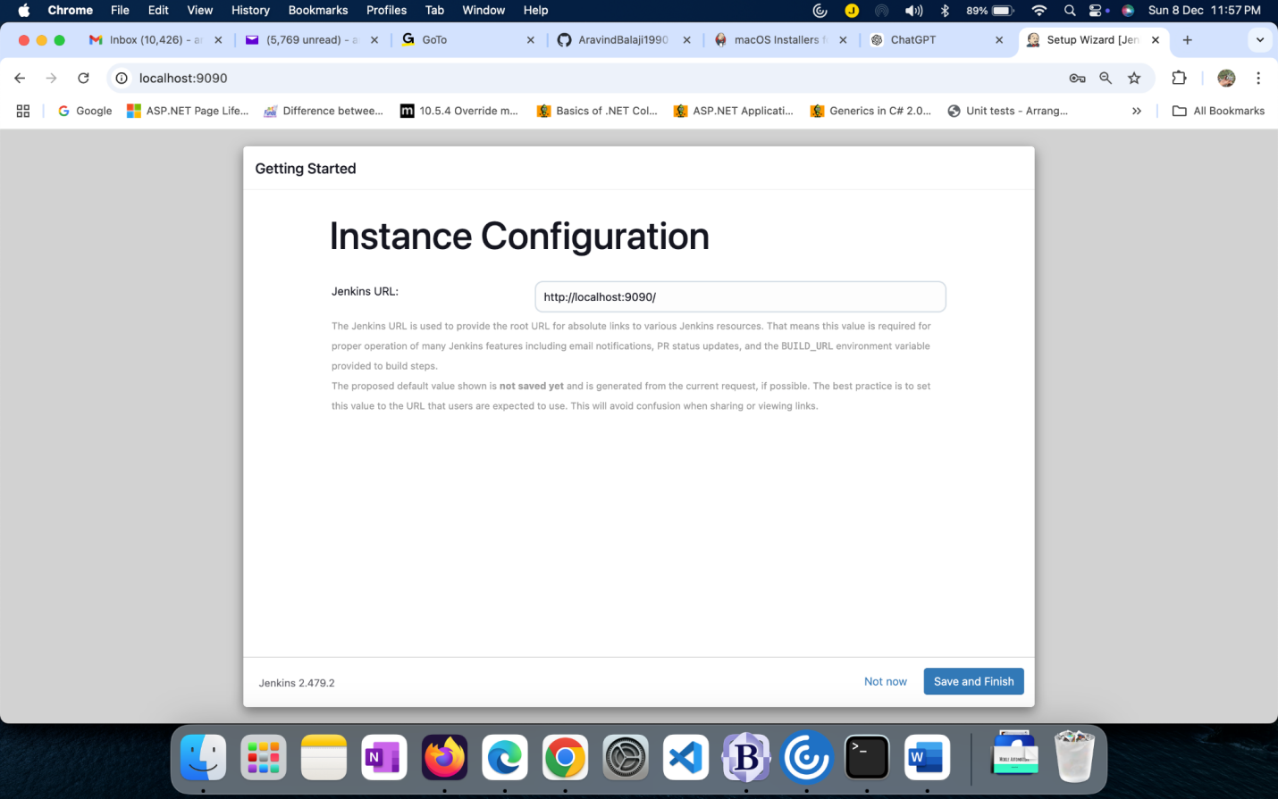

How to run appium in jenkins ?

<http://localhost:9090/login?from=%2F>

Pre-requisite:

1. Install plugins by visiting Dashbaord→ Manage Jenkins→ PLugins→Available plugins→ [Maven Integration plugin Version](https://plugins.jenkins.io/maven-plugin), Pipeline Maven PLugin API , Nodejs
2. Setup the node under the Dashbaord-> Manage Jenkins -> Tools , scroll till the end you will see the Nodejs make it as in below screenshot

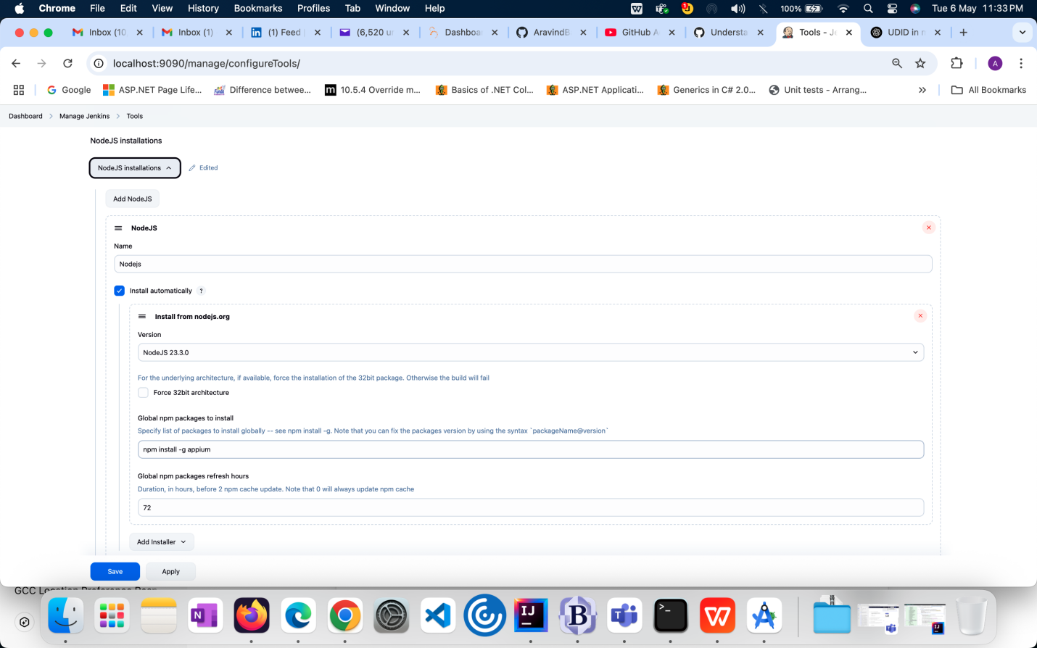

1. JDK in the same page as below

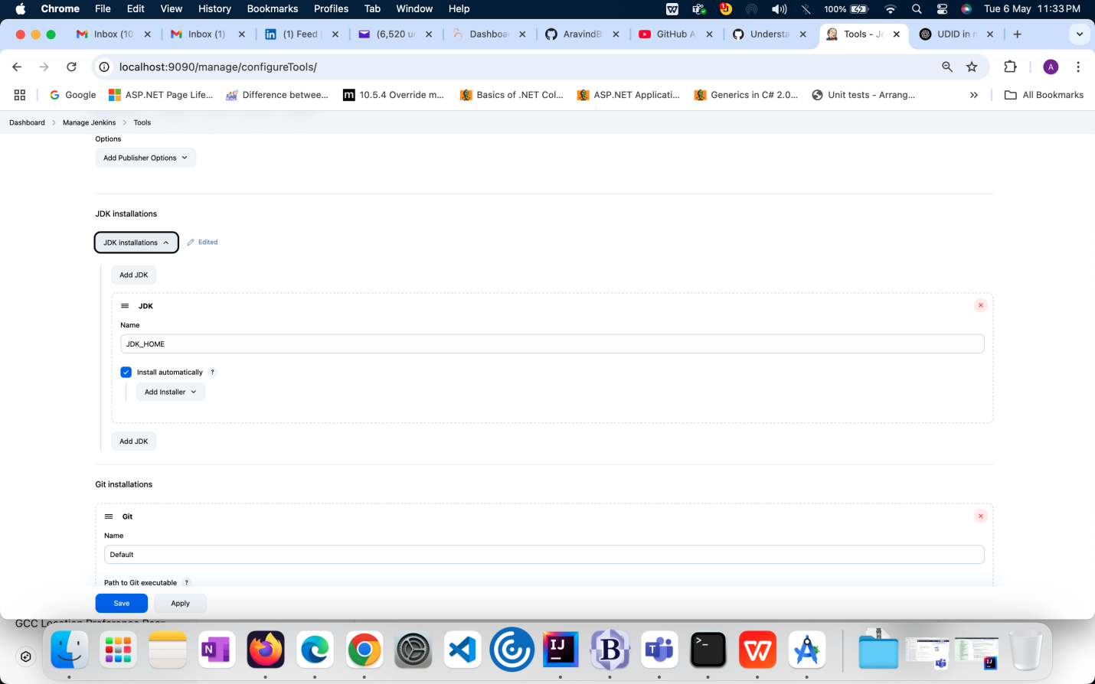

1. Maven in same page as in below screenshot

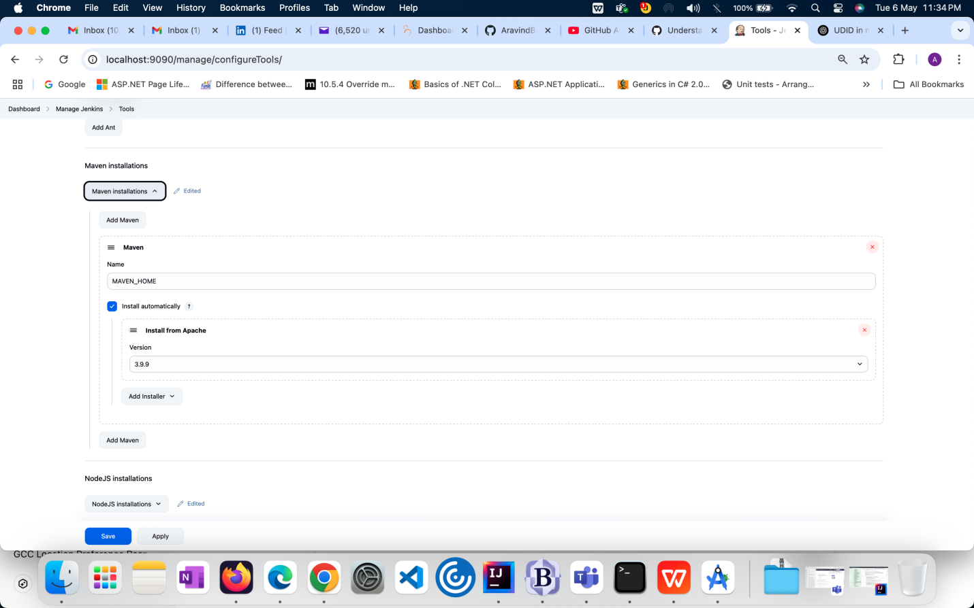

**Steps to create a job:**

1. Create a freestyle project with any name
2. Configure the git hub with username/password
3. Configure build steps as below steps,

